26 Sept 2026:
The outlier screen is a Python pass over the three FreeSurfer tables already extracted. It does not rerun recon-all, and it does not read the QC checklist.
Upstream, already finished before the screen. Each T1 was an independent FreeSurfer 8.2.0 recon-all -all.
aparcstats2table and asegstats2table wrote:
- tables/lh.aparc.thickness.csv
- tables/rh.aparc.thickness.csv
- tables/aseg.volume.csv
Those files cover 59 scans. sub-105822 mild is absent because that scan has no aparc output.
The screen itself is analysis/outlier_screen.py (pandas and numpy only). Running it writes tables/outlier_screen.csv (234 rows: 6 measures × 19 mild pairs + 6 × 20 moderate pairs).
For each scan it keeps six locked measures: bilateral mean of left and right mean thickness, rostral middle frontal, superior temporal, and temporal pole, plus left+right caudate and left+right hippocampus. Motion condition comes from the FreeSurfer ID (acq-standard = still, acq-headmotion1 = mild, acq-headmotion2 = moderate).
The quantity screened is within-subject percent change from that subject’s still scan, computed separately for mild and for moderate:
100×(motion−still)/still
A robust flag is an Iglewicz–Hoaglin modified z above 3.5 on that percent change: 0.6745×(x−median)/MAD, with the median and MAD taken inside that measure and that contrast. Two extra columns are stored and are not the inclusion rule: a Tukey 1.5×IQR fence, and an ENIGMA-style z using mean and sample standard deviation with a cutoff of ±2.698. Surface-hole count from aseg is copied onto each row. It is not part of the flag.

**The Iglewicz–Hoaglin modified z-score is a statistical method designed to identify outliers in a dataset, particularly when the dataset is small or when extreme values might distort the results of traditional methods.
It was proposed by Boris Iglewicz and David Hoaglin in 1993 as a more robust alternative to the standard z-score. The key difference is that it uses the median and the Median Absolute Deviation (MAD) instead of the mean and standard deviation, making it much less sensitive to the very outliers it is trying to detect.
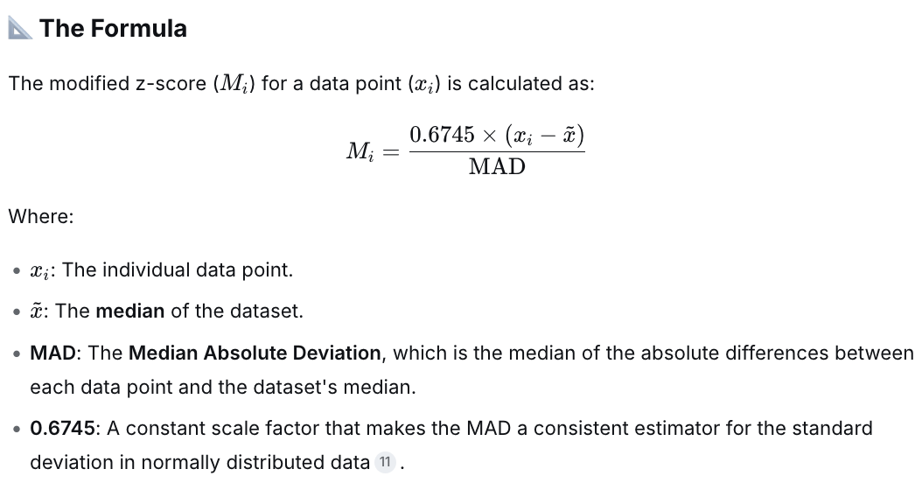

🎯 How It's Used for Outlier Detection
Once you calculate the modified z-score for each data point, you compare its absolute value to a threshold. The standard recommendation from Iglewicz and Hoaglin is:

🧠 Why It's Suggested for Your MRI Comparison
Your case involves comparing three MRI scans from the same subject, where head motion is a variable. This is a perfect scenario for the modified z-score for two key reasons:
- Small Sample Size: With only three scans, traditional outlier detection (which relies on large samples and the standard deviation) is unreliable. A single scan with high motion could inflate the standard deviation, making the other scans appear artificially consistent.
- Robustness: The method relies on the median, which is not affected by a single extreme value. This means that even if one of your three MRI scans has significant motion artifacts (an outlier), it will not "mask" the relationship between the other two scans. The modified z-score can more effectively flag that one scan as an outlier compared to the rest.
In essence, this model is suggested to help you objectively determine if one of the three MRI scans is an outlier due to motion, by comparing each scan's motion metric (e.g., framewise displacement) against the median of the three.

Re-examining each metric at n = 57

1. Modified z-score (Iglewicz–Hoaglin)
- Now computed over 57 values (or over 3 values per subject, depending on implementation).
- With n = 57, the median and MAD are well-defined and stable — this is exactly the regime where the modified z-score shines.
- Cutoff ±3.5 is now statistically meaningful (it wasn't really at n = 3).
- Robust to the masking problem: one very high-motion scan among 57 won't inflate the MAD the way it would inflate the SD.

2. Tukey 1.5×IQR fence
- Now much more meaningful. With 57 values, Q1 and Q3 are properly defined (they sit on actual data points or interpolate cleanly between them).
- This is a legitimate, standard outlier rule at this sample size.
- Still less sensitive than the modified z-score for skewed distributions (MRI motion metrics are typically right-skewed), but no longer fragile.

3. ENIGMA-style z (mean/SD, cutoff ±2.698)
- Here's the critical issue: the cutoff ±2.698 was derived from a t-distribution with df = 2 (i.e., n = 3).
- At n = 57, the correct two-tailed critical value at ~95% is approximately ±2.00 (z-distribution) or ±2.003 (t with df = 56).
- So if the pipeline still uses ±2.698 with n = 57, that threshold is too conservative — it will flag far fewer scans than intended. It's essentially applying a small-sample cutoff to a large-sample problem.
- Unless the ±2.698 is applied within each subject (n = 3 per subject), in which case it's correct. This is the ambiguity you should check in your pipeline.

4. Surface-hole count from aseg
- Now genuinely useful as a covariate: you can check whether high-motion scans (flagged by the z-scores) also have high hole counts.
- "Copied onto each row" means each subject's hole count appears 3 times (once per scan). If hole count is computed per scan's aseg, then it should not be copied — each scan would have its own value. If it's computed per subject (e.g., from a single reference segmentation), then copying is correct.
- Worth verifying: is the hole count per-scan or per-subject?

The bigger question this design raises
With 19 subjects × 3 scans, you have a repeated-measures design.

Option A: Pooled outlier detection (57 rows together)
- Simple, but conflates within- and between-subject variance.
- A subject with consistently high motion across all 3 scans will have all 3 scans flagged — but that might be a subject-level effect (e.g., anxiety, tremor), not a scan-level artifact.
- Not ideal if your goal is to pick the best scan per subject.

Option B: Within-subject outlier detection (3 rows per subject)
- For each subject, compute the modified z-score across their own 3 scans.
- Flags the scan(s) that are worse relative to that subject's own baseline.
- This is almost certainly what you want if the goal is to select the cleanest scan per subject.
- Problem: with n = 3, the modified z-score is unstable (as discussed earlier). The MAD of 3 values is coarse.

Option C: Mixed-effects / hierarchical approach
- Model scan-level motion as a function of subject (random intercept) plus scan-level noise.
- Extract residuals and flag scans with large residuals.
- Statistically the most correct for repeated measures, but more complex.

Option D: Between-subject + within-subject combined
- Compute a subject-level summary (e.g., median motion across 3 scans) → flag outlier subjects using modified z-score across 19 values.
- Then, within non-outlier subjects, pick the best scan.
- This separates "this subject is problematic" from "this scan is problematic."

What I'd recommend you check in your pipeline
- Is the modified z-score computed over 57 rows or 3 rows per subject? This determines whether you're detecting scan-level or subject-level outliers.
- Is the ENIGMA-style z cutoff ±2.698 applied at n = 3 or n = 57? If n = 57, the threshold is mis-calibrated.
- Is the Tukey fence computed over 57 rows or per subject? Same issue.
- Is the surface-hole count per-scan or per-subject? If per-subject, "copied onto each row" is correct; if per-scan, copying would be a bug.
- What is the actual inclusion rule? The fact that these are "not the inclusion rule" means something else is gating. Find out what — it may be a motion threshold (e.g., mean FD < 0.2 mm) applied independently.

Quick numerical intuition
Suppose across 57 scans, motion (mean FD) has:
- Median = 0.15 mm
- MAD = 0.05 mm
A scan with FD = 0.40 mm gets a modified z-score of:
M=0.6745×(0.40−0.15)0.05=0.6745×0.250.05=3.37M=0.050.6745×(0.40−0.15)​=0.050.6745×0.25​=3.37
That's below 3.5, so not flagged — even though 0.40 mm is quite high. This illustrates that the modified z-score is conservative; it flags only extreme outliers relative to the cohort's spread.
If instead the mean/SD were 0.18/0.12, the ENIGMA z would be:
z=0.40−0.180.12=1.83z=0.120.40−0.18​=1.83
— also not flagged at ±2.698 (and barely at ±2.00).
So both metrics might miss a scan you'd want to exclude on absolute grounds. This is why pipelines often combine relative outlier detection (z-scores) with absolute thresholds (e.g., FD > 0.5 mm = exclude regardless).

